Analysis of Bangalore Restaurants

Samriti Attrey

# Introduction

## Background

Bangalore is the capital and largest city of the Indian state of Karnataka. It is famous for traffic 24/7. With a population of over 15 million (as of January 2016), Bangalore is the third largest city in India and 27th largest city in the world. The diversity of the cuisine available is reflective of the social and economic diversity of Bangalore. Roadside vendors, tea stalls, South Indian, North Indian, Arabic food, Chinese and Western fast food are all very popular in the city.

## Problem

The project aims to list and visualize all major parts of Bangalore City. This analysis will be useful for foodies who are living or newly shifting to Bangalore and will be able to decide the locality they can explore basis their food preferences. The insights obtained from this analysis will also be relevant to existing restaurant owners and to the people planning to open a new restaurant.

## Questions addressed using this analysis

* How popular is online ordering in Bangalore? Is there a relationship between ratings and online ordering option in restaurants?
* How many restaurants have option to book a table online? Is there a relationship between ratings and online booking table option in restaurants?
* Which restaurants have maximum number of venues across the city?
* Top 10 costliest restaurants in city and top 10 cheapest restaurants in city.
* Which location in Bangalore has the highest rated restaurants?
* Which type of restaurants are most popular in Bangalore?
* Maximum restaurants of which type are present in each location.
* Which location in city has maximum and minimum number of restaurants across the city?
* Top venues in each neighborhood/locality
* Which locations in Bangalore are similar in terms of nearby venues?

# Data acquisition and cleaning

## Data sources

For this project we used the following data:

* Bangalore Restaurants data that contains list Neighborhood, Restaurant name, Rating along with their latitude and longitude.

Data source: [Kaggle Dataset](https://www.kaggle.com/himanshupoddar/zomato-bangalore-restaurants/download)

Description: This data set contains the required information. And we will use this data set to explore various locality of Bangalore city.

* Nearby places in each locality of Bangalore city.

Data source: [Foursquare API](https://developer.foursquare.com/)

Description: By using this API, we will get all the venues in each neighborhood.

* Neighborhood coordinates of each locality of Bangalore city.

Data source: Geocoder python

## Feature selection

After data cleaning, there were 51,717 samples and 17 features in the data. Upon examining, there were 30 different neighborhoods across the city and 6884 unique restaurants which have been analyzed in the project. The columns that have been chosen for analysis are: name, online_order, book_table, rate, location, cuisines, approx_cost(for two people) ,listed_in(type), listed_in(city), rest_type.

# Exploratory Data Analysis

## Calculation of percentage of restaurants with feature of online ordering

With the advent of online ordering, its popularity grew with time. In the Zomato dataset, we examined that there is online ordering option available across multiple restaurants. Popularity of online delivery option in Bangalore has been calculated in Figure 1.

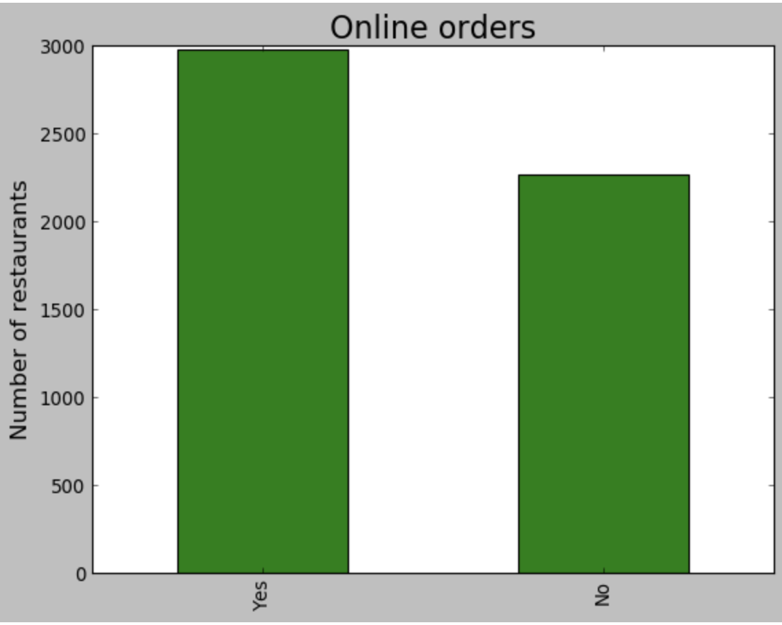**Figure 1: This concluded that 59% of restaurants have Online ordering option available**.

## Relationship between online ordering and restaurant rating

The hypothesis is that online ordering option should affect rating of the restaurant positively.

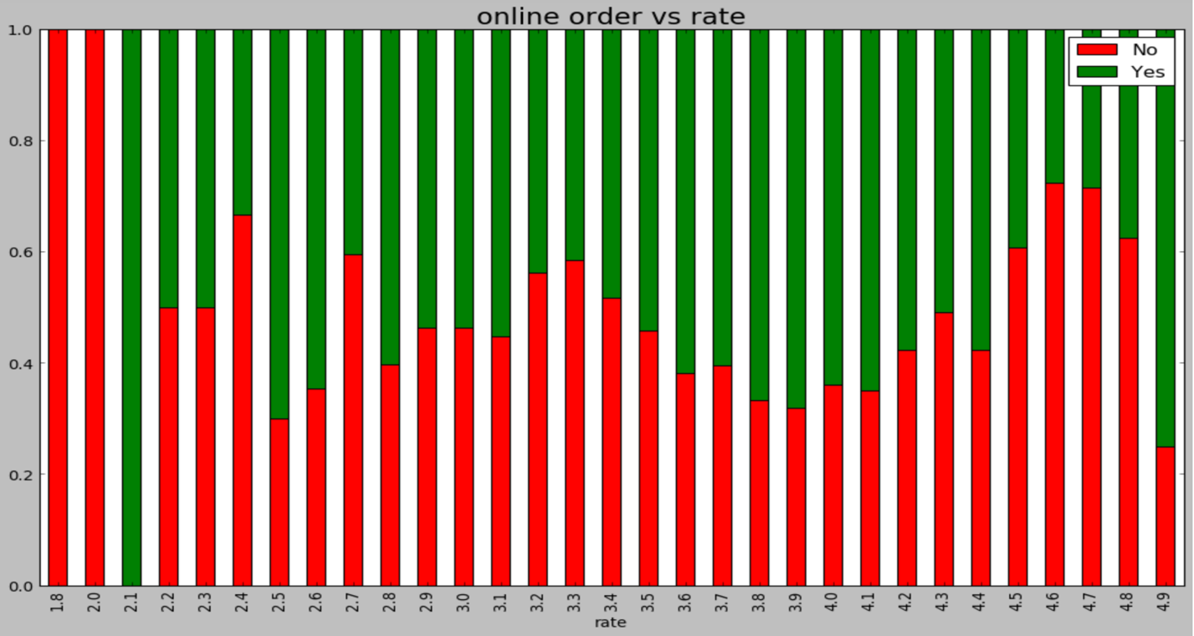

**Figure 2: Stacked bar chart showing Rating vs Online ordering**

From the plot (Figure 2), it is examined that the restaurant is likely to receive higher rating if it has online ordering option available.

## Calculation of percentage of restaurants with feature of booking option

## 

**Figure 3: This concluded that 9.2% of restaurants have booking option available.**

Online booking option is supposed to make the customer experience better with reduced waiting time.

## Relationship between online booking option and restaurant rating

The hypothesis is that online ordering option should affect rating of the restaurant positively.

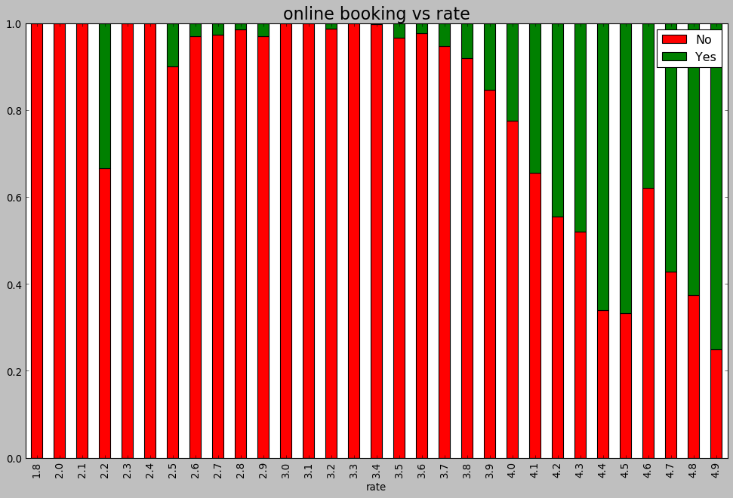**Figure 4: Stacked bar chart showing Rating vs Online booking table**

From the plot (Figure 4), it is examined that the restaurant is likely to receive higher rating if it has online booking option available as it will improve the customer experience with reduced waiting times.

## Finding most popular restaurants in Bangalore

## 

**Figure 5: Topmost popular restaurants in Bangalore**

It can be concluded from Figure 5 that “**Café Coffee Day**” is most popular with more than 60 venues across the city followed by “**Baskin Robbins**”.This insight is useful for people who want to invest into an established food chain in Bangalore.

## Finding costliest restaurants in Bangalore

## 

**Figure 6: Topmost costliest restaurants in Bangalore**

It can be concluded from Figure 6 that “**The Leela Palace**” is costliest with more than 6000 cost across the city followed by “**Radisson Blue**”.

## 3.6 Finding cheapest restaurants in Bangalore

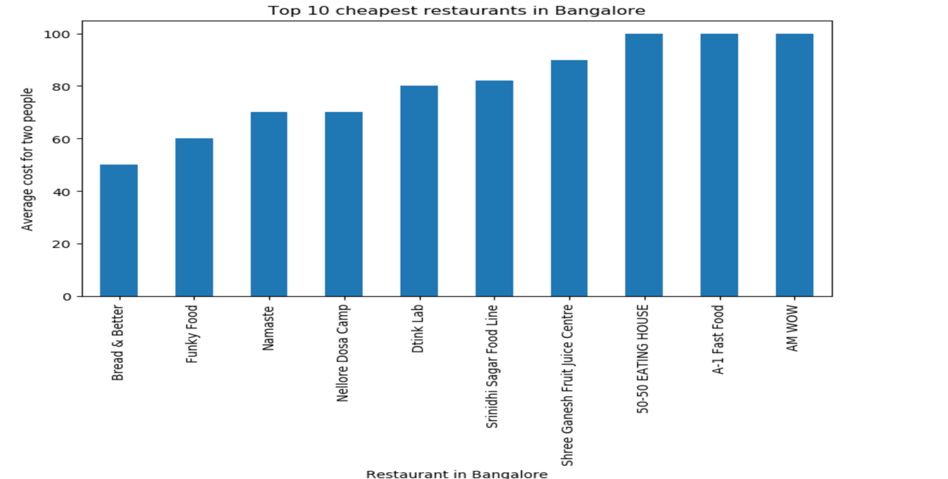

**Figure 7: Topmost cheapest restaurants in Bangalore**

It can be concluded from Figure 7 that “**Bread & Better**” is cheapest across the city followed by “**Funky Food**”.

## Finding the locality with highest rated restaurants in Bangalore

## 

**Figure 8: Localities with the highest rated restaurants in Bangalore.**

It can be concluded from Figure 8 that “**Lavelle Road**” has highest rated restaurants across city.

## Finding the most popular restaurant type in Bangalore

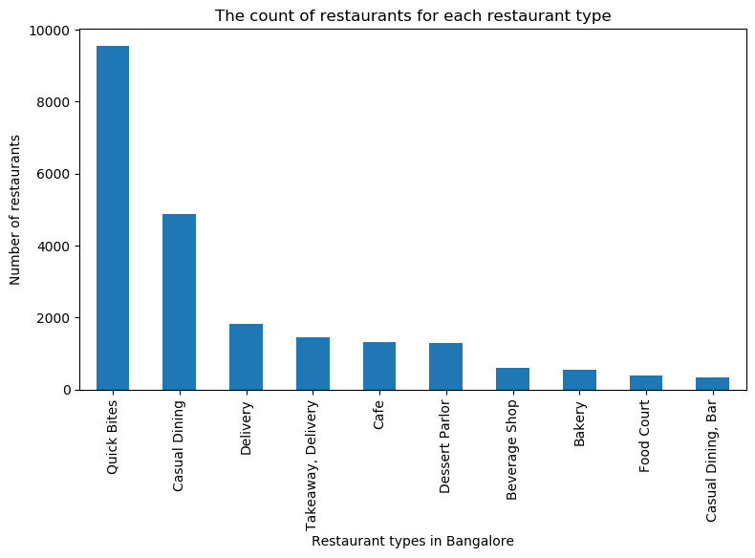

**Figure 9: Restaurant types in Bangalore**

It can be concluded from Figure 9 that “**Quick Bites**” type of restaurants is the most popular followed by “**Casual Dining**”. Also “**Desert Serving**” places are more than “**Bars**” in the city.

## Finding the most popular restaurant type in each locality of Bangalore

## 

**Figure 10: Popular Restaurant types across locations in Bangalore**

It can be concluded from Figure 10 that “**HSR & Koramangala 4th block**” have “**Delivery**” as the most popular type of restaurant amongst other types.

# Segmentation and Clustering

Clustering methods are used to identify groups of similar objects in a multivariate data set. We use partitioning segmentation technique by using k means clustering to divide similar neighborhoods and create clusters.

Using Foursquare API, we find the nearby venues for each location/neighborhood. We get the common venues around each locality and top 10 venues for each locality.

Top venues around each neighborhood:

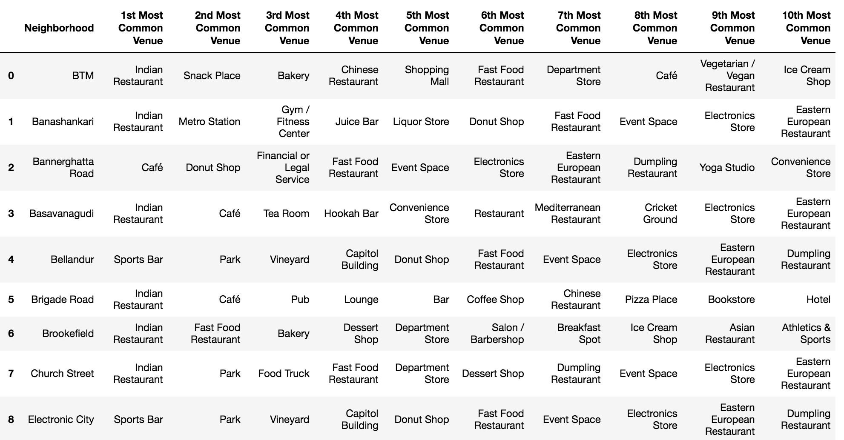

We run k means clustering to identify different localities which have similar venues nearby which are visualized in the below Figure 11.

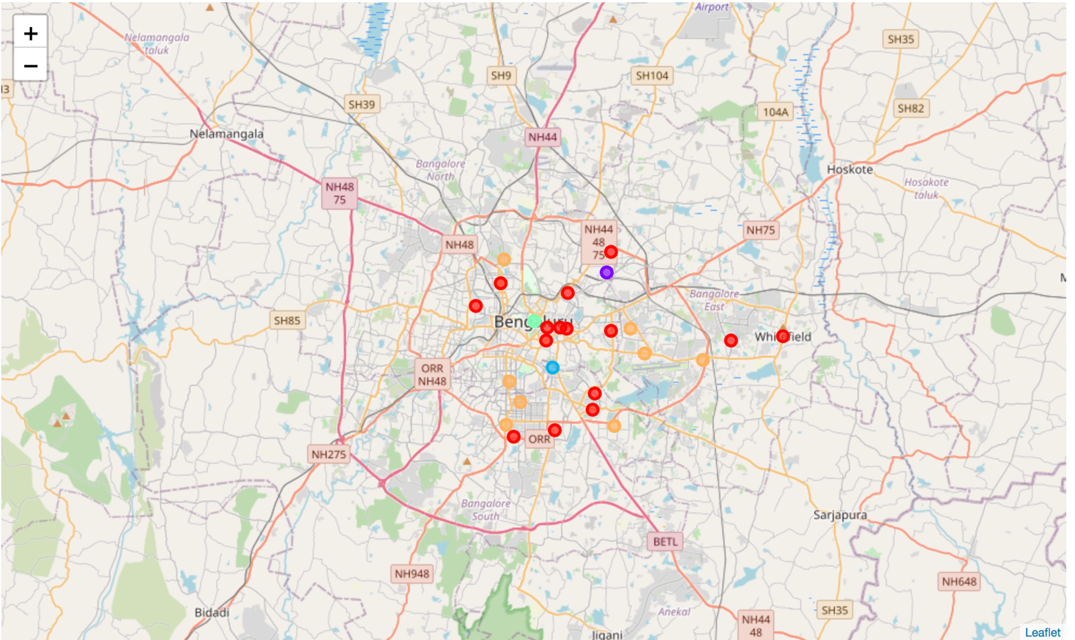

Figure 11: Different clusters of locality across Bangalore.

**Cluster 1**

Indian Restaurants and Gym/fitness centers are the most recommended venues near these locations



**Cluster 2**

Diners are the most recommended venues near these locations.

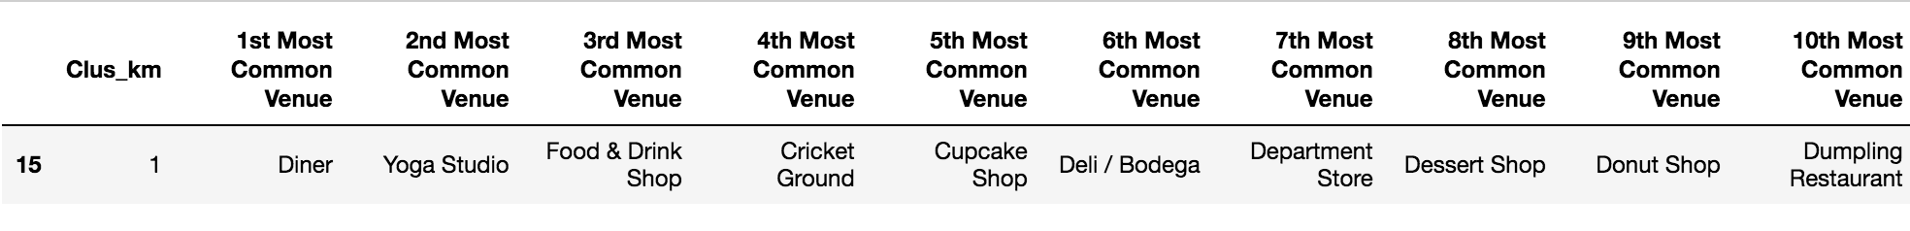

**Cluster 3**

Cafes are the most recommended venues near these locations.

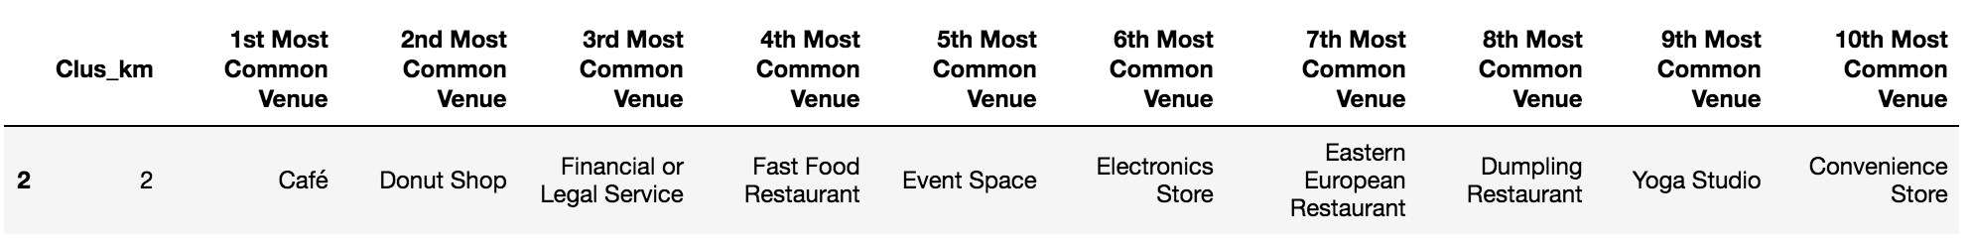

**Cluster 4**

Sports Bar are the most recommended venues near these locations

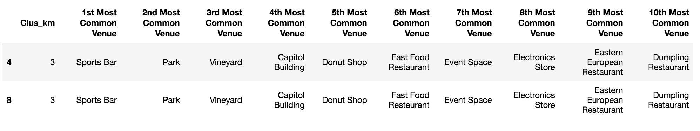

**Cluster 5**

Indian Restaurants and Cafes are the most recommended venues near these locations

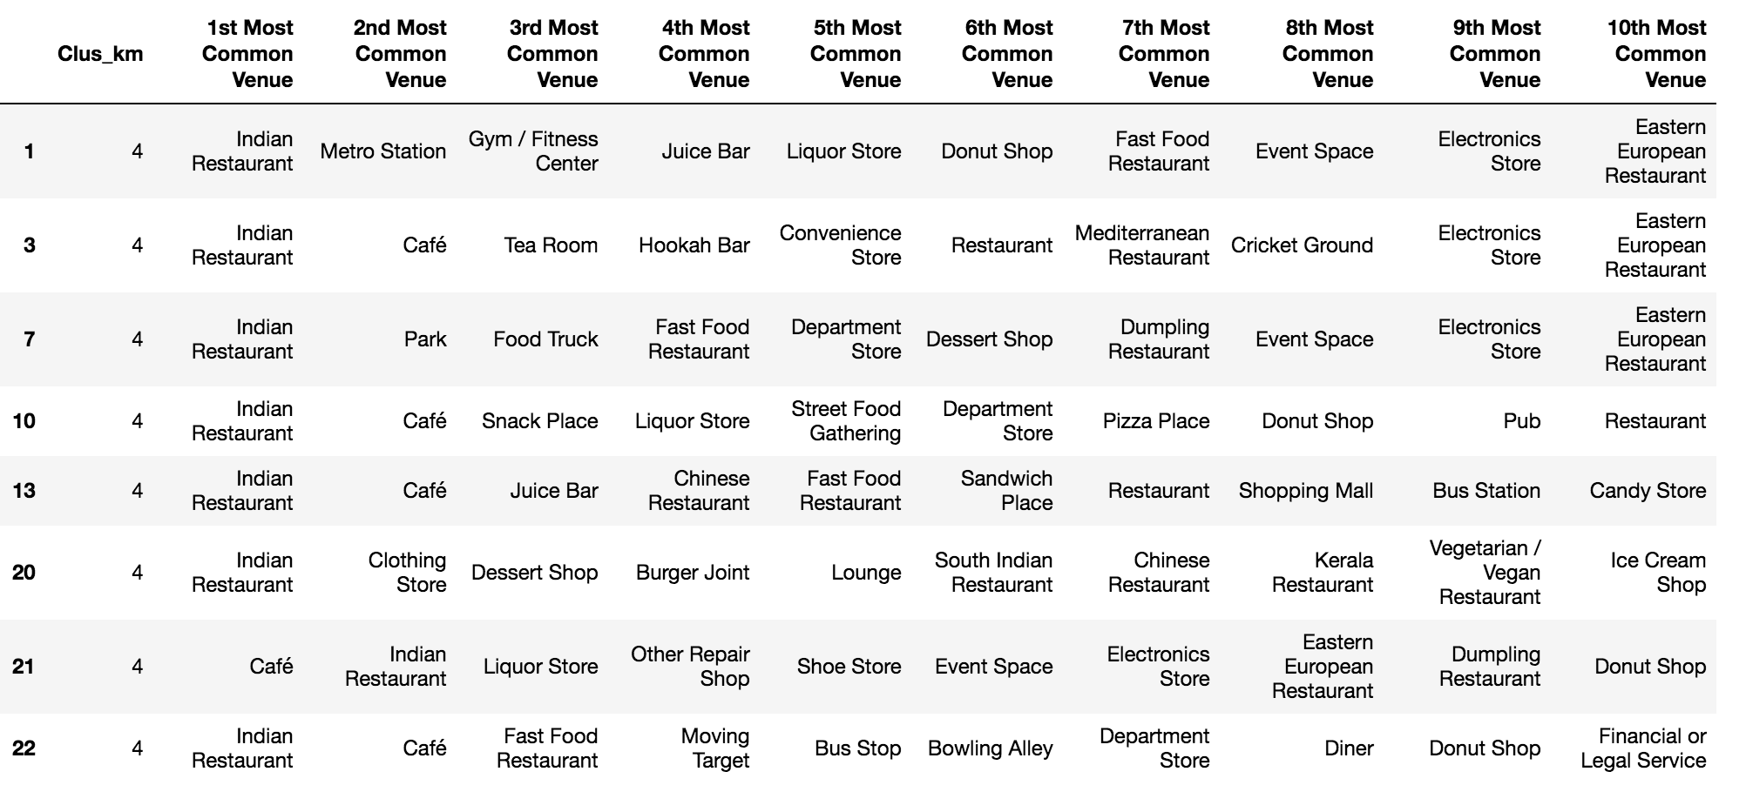

# Results and Discussions

Our analysis shows that there are huge number of restaurants in Bangalore and food culture is very prominent across different locations/neighborhoods of Bangalore. Analyzing the online ordering option availability for restaurants across Bangalore, we realized that there are 48% restaurants which have online delivery available through Zomato. Next, we decided to seek a relationship between the availability of delivery option and rating of the restaurant. It was observed that the restaurant with online delivery option is likely to get a higher user rating.

Next, analyzing the booking table option through Zomato app, we found that 9.2% out of total have a booking option available. Further, there is a positive correlation between the booking option and the restaurant rating. This insight can be utilized by the restaurant owners that if they keep the booking table option on the app, they will get better ratings due to better customer experience with reduced waiting time.

Next, we analyzed the restaurant chains with maximum venues across Bangalore. Out of which ‘Cafe Coffee Day’ had close to 60 venues across the city being the highest, followed by ‘Baskin Robbins’. This insight can be utilized by people who want to invest and open a currently established food chain and see the popularity.

Next, cost for two people was analyzed across the restaurants. ‘The Leela Palace’ was the costliest with cost of around 6000 Rupees for two people followed by ‘Radisson Blue’ with 5500 and ‘JW Marriott’ with 4000 cost.

Cheapest were analyzed with the lowest being ‘Bread and Better’ and ‘Funky Food’.

Next, analysis was done to identify neighborhoods with the highest rated restaurants in the city. ‘Lavelle Road’ topped the list having highest rated restaurants in Bangalore and can be a go-to option for foodies to explore the highest rated restaurants.

Next, analysis was done to identify the restaurant type which is most popular across Bangalore. ‘Quick Bites’ type of restaurants were most in number, followed by casual dining. Also, ‘Desert serving’ places were more than ‘Bars’ across the city.

Next, analysis was done for all neighborhoods to identify the most popular restaurant type in each area. It was found out that ‘HSR and Koramangala’ have maximum delivery options available compared to other restaurants in the area. This is a useful insight for foodies for them to decide their living place basis the popularity of restaurant types available nearby.

Also, we found out the places with the maximum restaurants in the city which was ‘BTM’. This is expected as BTM is majorly occupied by bachelors and hence the largest number of eating joints. On the other hand, minimum restaurants in city were in ‘Lavelle Road’.

After this, the city was divided into clusters basis the nearby venues in the locality/neighborhood through k-means clustering. We found that there were similar neighborhoods which could be clustered together basis the nearby venues. The result was that the city was divided into five clusters. Indian Restaurants and Gym/fitness centers were the most common venues near the Cluster 1 which were the similar locations like Brigade Road, M.G Road.

Similarly, insights were drawn for Cluster 2 where Diners were the most common, Cluster 3 where Cafes were recommended, Cluster 4 where Sports Bar are popular and Cluster 5 with Cafes and Indian Restaurants in areas like Marathahalli and HSR.

# Results and Discussions

Purpose of this project was to analyze the restaurants in different neighborhoods across the city. This analysis is useful for foodies to decide the places they can visit basis their budget and preferences, locations where there are highest rated restaurants, locations with popular online delivery options etc. The relationship between online ordering and booking table options on Zomato app with the restaurant ratings was identified and can be utilized by restaurant owners for better customer experience. The clustering exercise done in the project is useful for the foodies who are living or shifting to Bangalore to decide the neighborhoods to explore and to the stakeholders who want to open a new restaurant chain or invest in an established food chain basis their popularity.